# Hands-on #12 : AWS Services Lambda & Glue & Athena : Serverless ETL Pipeline

**Manisha Chowdary Aeinedi**

**801419098**

**Step-by-step setup**

1. **Create the bucket and folders**

* **Create an S3 bucket, for example online-orders-pipeline.**
* **Inside it, add two empty folders named raw/ and processed/.**

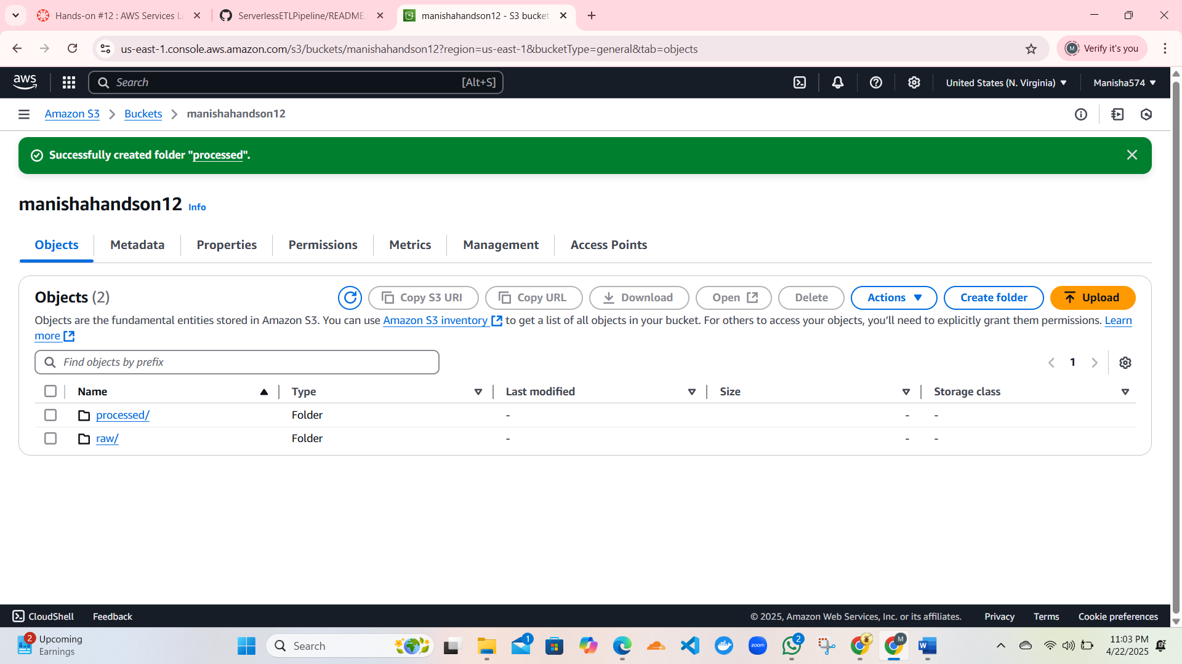

**2.Uploading the raw file “orders.csv”**

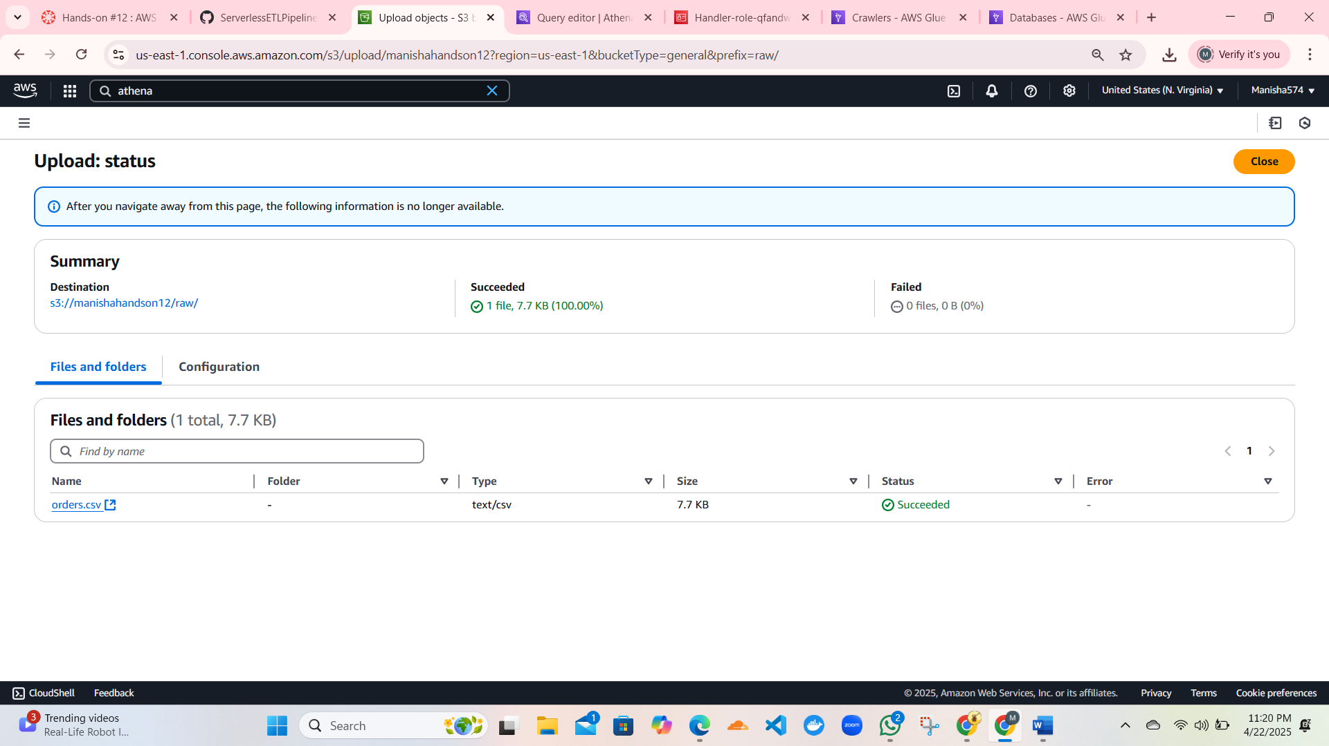

**3.Adding permissions to “handler” role.**

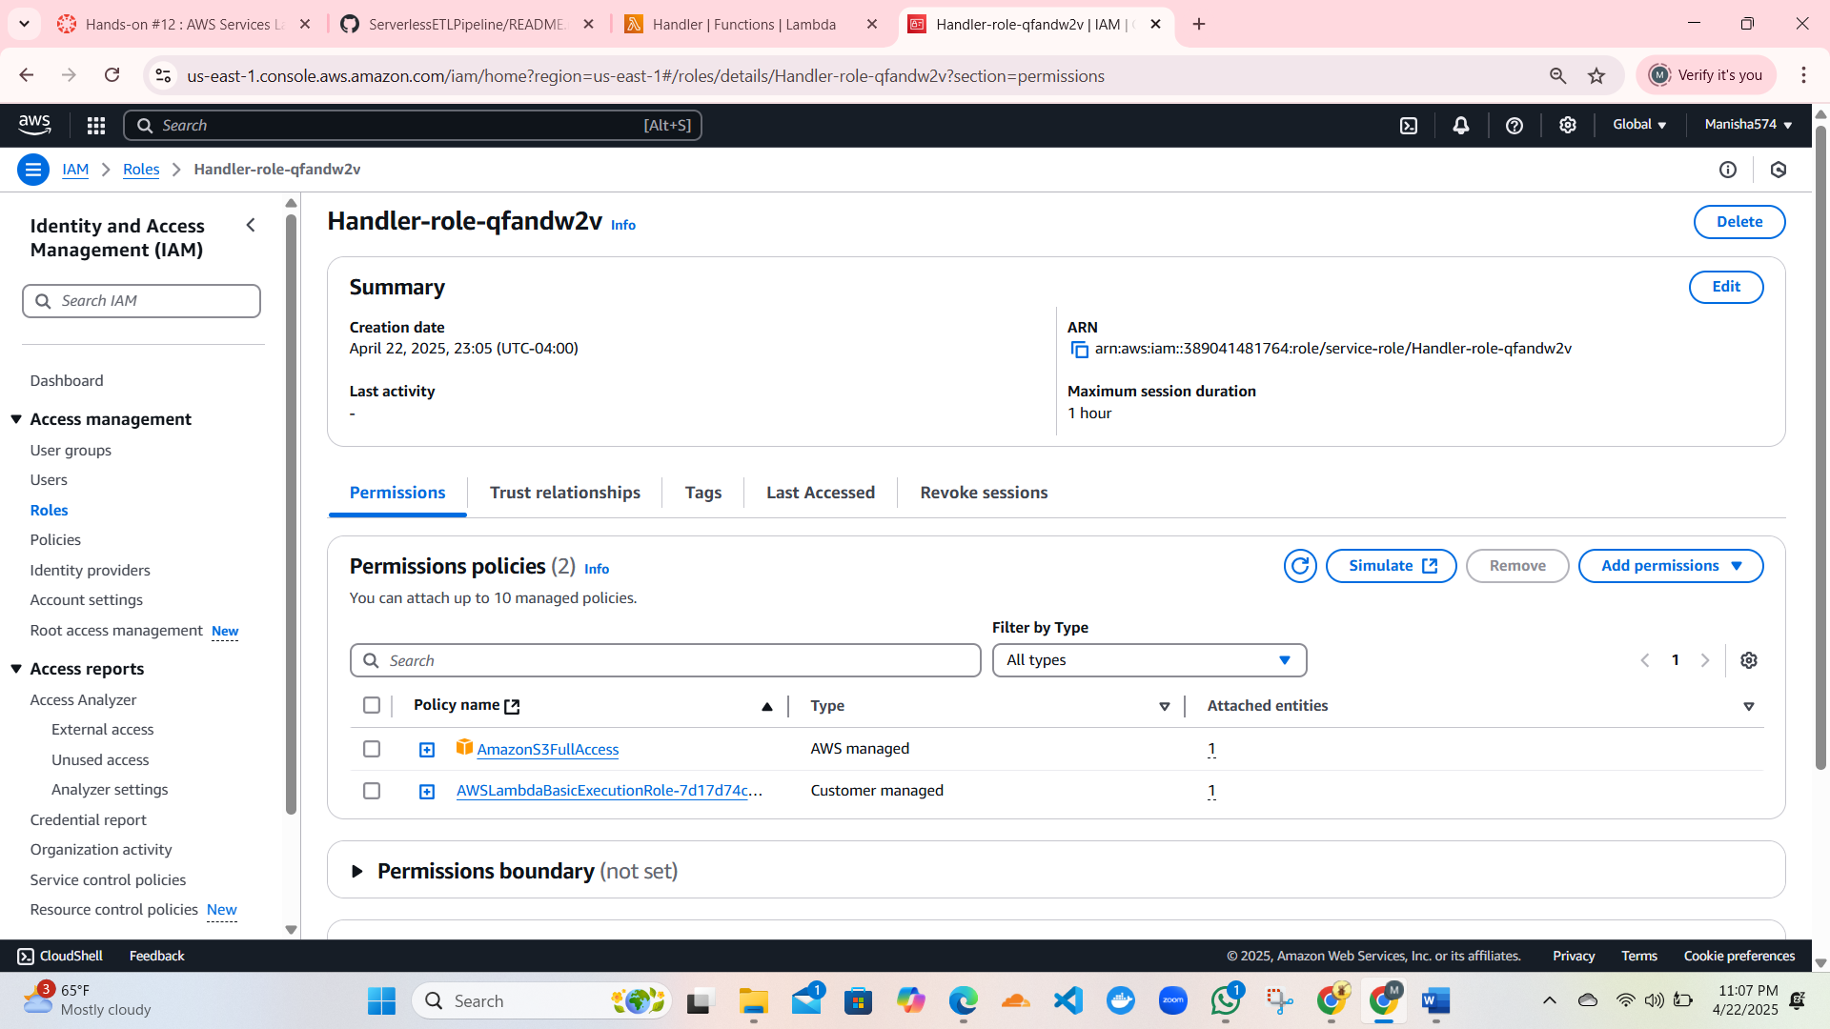

**4.Creating crawler:**

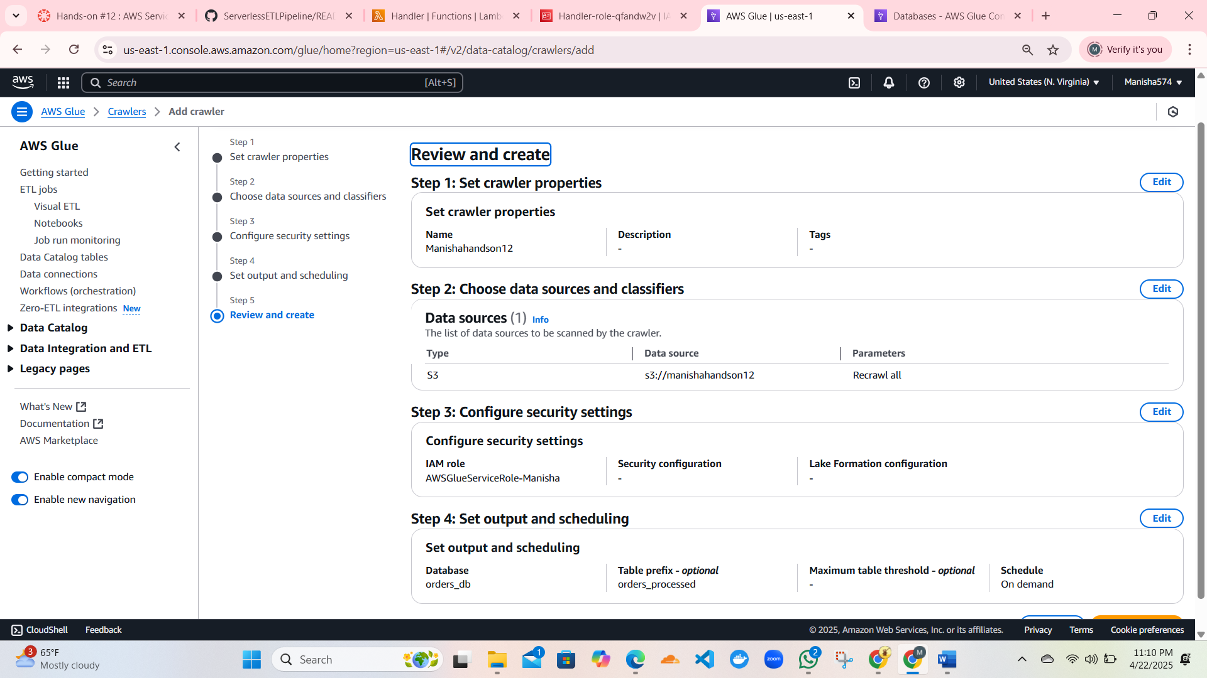

**5.Query the data with Athena**

**Make sure Athena’s query-result location is set, then run:**

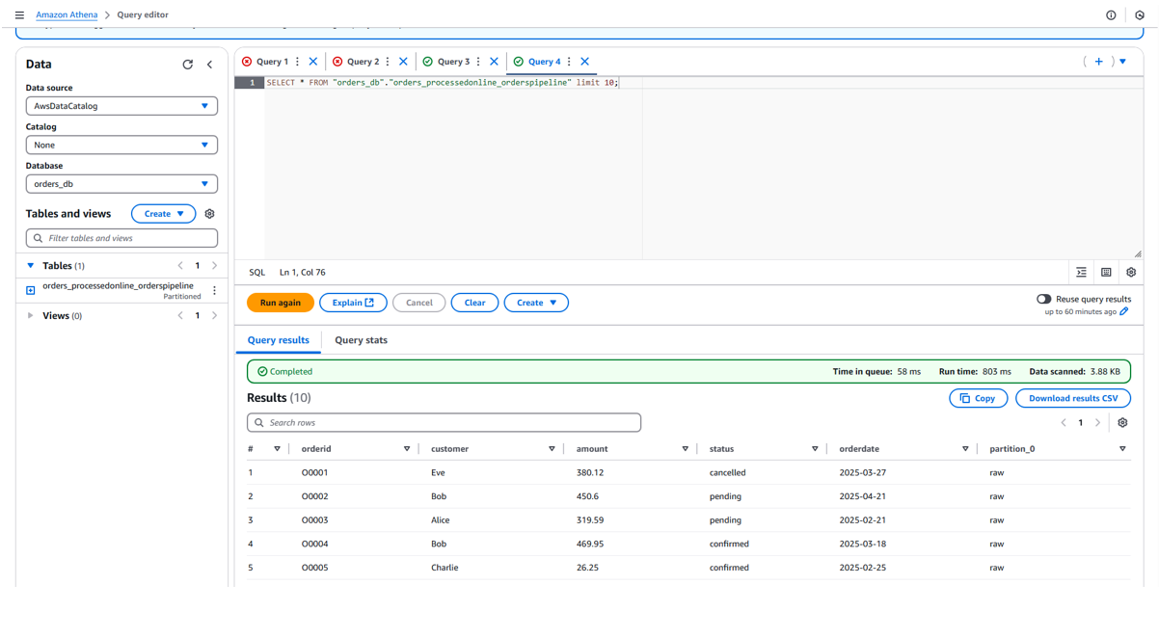

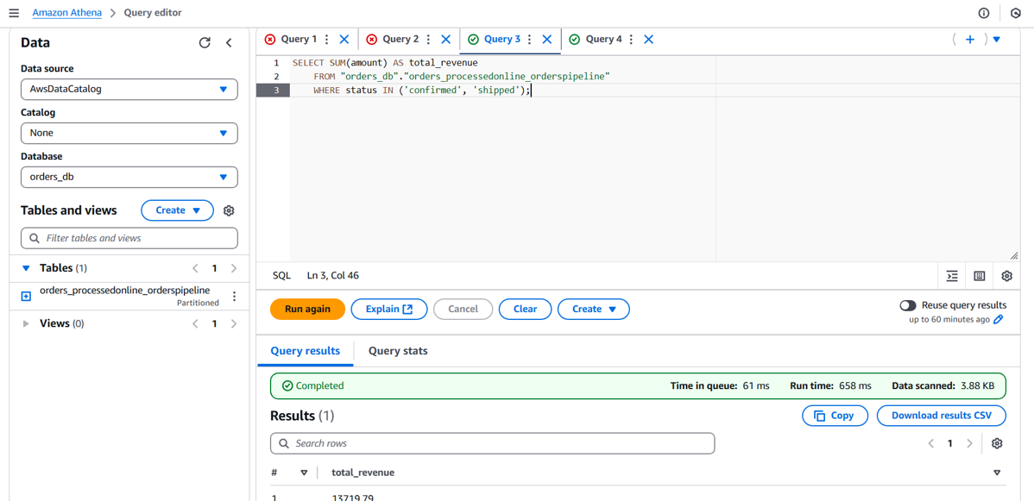

**6. CloudWatch logs**

**CloudWatch Logs ➜ Log groups ➜ /aws/lambda/<function-name>**

